# mieke willems: spirograph

# Introduction to spirograph simulation in MATLAB

# Muhammad Shamaas

# ID # MC220204248

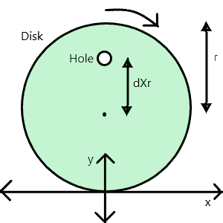

The hole is dr from the center of disk. Where r is the radius of disk.

If the disk rotates by Ɵ radians, the new coordinates of the hole will be:

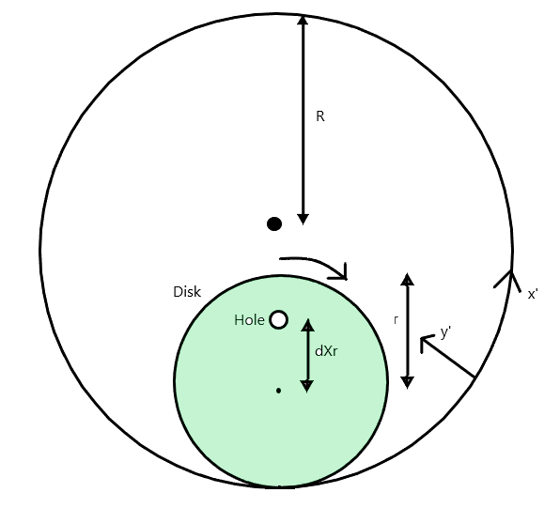

If the disk rotates inside a bigger disk of radius R, the new coordinates are:

**Results**

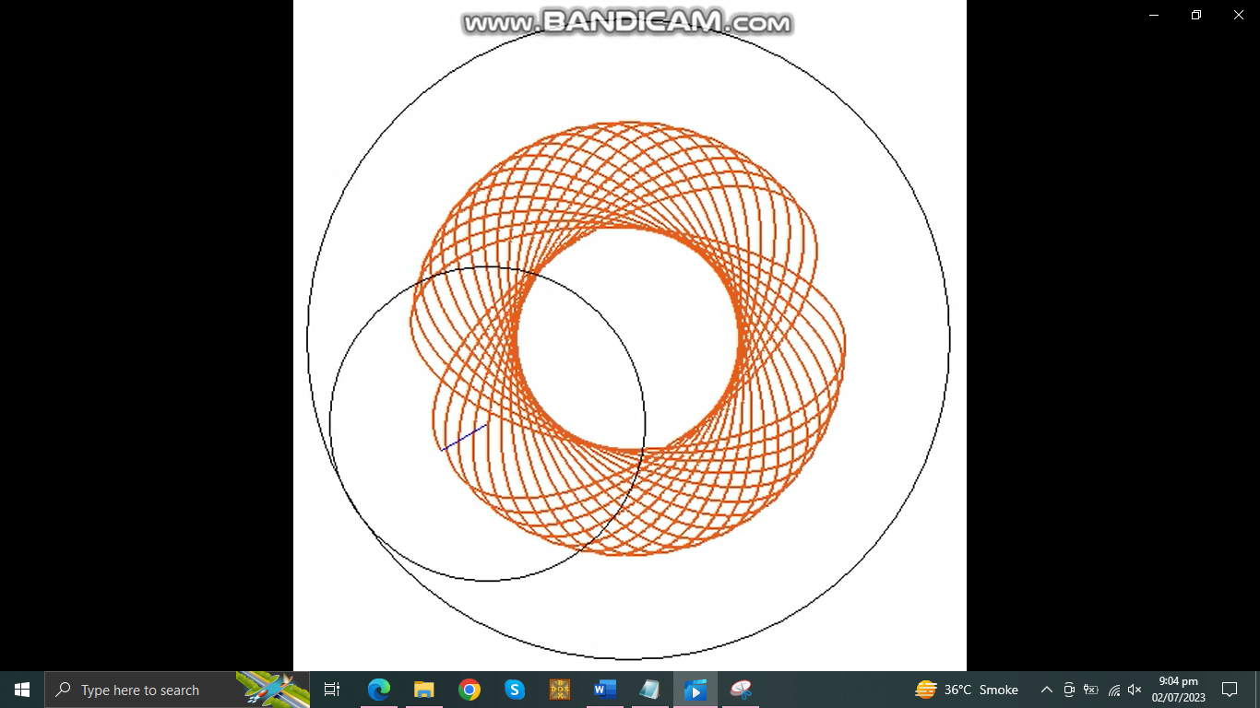

MATLAB Code:

R = 100;

figure;

pause(2);

axis('equal');

axis([-R-10,R+10,-10,2*R+10])

hold on;

radius = R;

center = [0 R];

pos = [center-radius 2*radius 2*radius];

rectangle('Position',pos,'Curvature',[1 1]);

for iter=1

%R = rand()*50;

r=rand()*R; %8.9117

f=0.0001;

dis = rand(); %0.6463

coordinates = [0,(1+dis)*r];

newcoordinates = [0,(1+dis)*r];

Ccoordinates = [0,(1+dis)*r];

Ccoordinatesnew = [0,(1+dis)*r];

c = [0 r/2];

color = [rand() rand() rand()];

offsetX = 0;%(rand()-0.5)*200;

offsetY = 0;%(rand())*200;

for t=0:(pi/360):(100*pi)

newcoordinates(1) = r*(t) + (dis*r)*sin(t);

newcoordinates(2) = r+(dis*r)*cos(t);

coordinates = newcoordinates;

theta = (r*t)/R;

center = [(R-r)*sin(theta) R-(R-r)*cos(theta)];

Ccoordinatesnew(1) = center(1)+dis*r*sin(t-theta);

Ccoordinatesnew(2) = center(2)+dis*r*cos(t-theta);

if (t~=0)

plot([offsetX,offsetX]+[Ccoordinates(1),Ccoordinatesnew(1)],[offsetY,offsetY]+[Ccoordinates(2),Ccoordinatesnew(2)],'color',color,'LineWidth',2);

end

radius = r;

theta = r*t/R;

center = [(R-r)*sin(theta) R-(R-r)*cos(theta)];

pos = [center-radius 2*radius 2*radius];

circle = rectangle('Position',pos,'Curvature',[1 1]);

line = plot([Ccoordinatesnew(1), (R-r)*sin(theta)],[Ccoordinatesnew(2), R-(R-r)*cos(theta)]);

if (rem(t,pi/6)==0)

pause(0.000001);

end

set(circle,'Visible','off');

set(line,'Visible','off');

Ccoordinates = Ccoordinatesnew;

end

pause(1);

end